**Design and Features**

This website will offer a modularised tasking system. A user can have many boards, boards represent the working space eg. Hotel, personal fitness, restaurant staff. A board can then have many task groups within it called projects. Within these projects are the individual specific tasks.

A modularised example is included below:

Board: Web database

Project: Milestone 1

Task: Research

Task2: Design

**Employee / Manager**

Users cannot have a specific role bound to their account. The user will have a specific role in the board, in one board they may be an employee and in another they may be a manager.

**Availability**

Their availability is specific to each board. For example, in board Web Database, they can have an availability of Monday to Tuesday and in board ADSA they can have an availability of Thursday to Friday. Their availability is set to the board, not to their account. This allows more specificity.

**Task**

Each board has their own task tags. The members of the board have an ability gauge for each of these task tags.

**Homepage**

The main page of this site is the current board selected and presents all tasks of the current day in a comprehensible table system. The main page serves as the hub for all operations, meaning operations will simply open a small window within the main page and the user stays on the main page. At the same time, adding tasks is done on the main page itself. Managerial operations such as add task are invisible to the employees of the board, while visible to their managers.

The user can change the main page from the side panel, by selecting a different board.

**Main page**

*Figure 1: Main page*

Side panel

* Toggle visibility
* Contains all board the user has. The user can navigate board to board from here
  + Has the option to add, rename, delete board and get board link.
  + Adding board creates a board set to the current date
* Links allow board to be shared
  + Clicking join button opens text field that accepts a link input and sends a request to the manager of the board.
* Contains request button
  + Requests contain invitation from managers to their board.
* Contains link to profile
  + Opens drop down menu to either log out or open profile

Board

* Shows the current tasks of the day using a comprehensible table system.
* Use the date toggle underneath the heading to switch days. The view will switch to the board’s tasks of that day.
* Task tags
  + Opens a small window. Managers think of the most commonly set tasks in the board and create the one-word tag. Will eventually show up as a list in the window.
  + Employees of the board click on a different button from the homepage, “My tasks” and set their ability to each task tag as “Great”, “Average” or “Needs improvement”.
* Members
  + Opens a small window. It will show a list of the members; their profile, availability and “task that can perform” button. Availability and tasks gives ability to open a small window. Profile task gives ability to go to the profile of that selected member
  + Contains the ability to add employees and manage the requests of outside employees in joining our board.
  + Contains the ability for Managers to accept or deny day off request.
* Bulk add
  + Opens a small window for creating a project or a single task. When creating, select the days for the project or task and many copies of that project or task will be created across the selected dates.
* My availability
  + Opens a small window to specify the user’s availability within the board. 7 bars represent 7 days, and the value in these bars represent the hours they are available. Employees can request day(s) off here by clicking on the calendar and submitting. Managers can review these requests in their members’ window.
* Filter
  + Drop down menu, select a member and the view will change so only tasks of that member is visible.
* Projects
  + Color coded heading, has a name and contains tasks
  + Add project:
    - Click add project
    - Name the project
    - Add tasks (see below)
* Tasks
  + Name, status (complete, in progress, stuck), person responsible, priority (urgent, high, medium, low)
  + Creating task:
    - Click add task
    - Name the task
    - Select task tag
    - Select time
    - While selecting person responsible, a dropdown of people will show up in row groups:
      * 1st group: available and great
      * 2nd group: available and average
      * 3rd group: available and needs improvement
    - Set priority
    - Set urgency
  + Completing a task:
    - Manager and employee change status to complete. Employee can complete the tasks they were set, managers can complete anyone’s task.

**Main page (index.html) site design**

*****Figure 2: Join window opens from clicking join in side panel. Background is of homepage that is greyed out.*

*Figure 3: Members window from clicking members button in the board*

*Figure 4: My availability*

*Figure 5: Tasks window*

*Figure 6: My Tasks window*

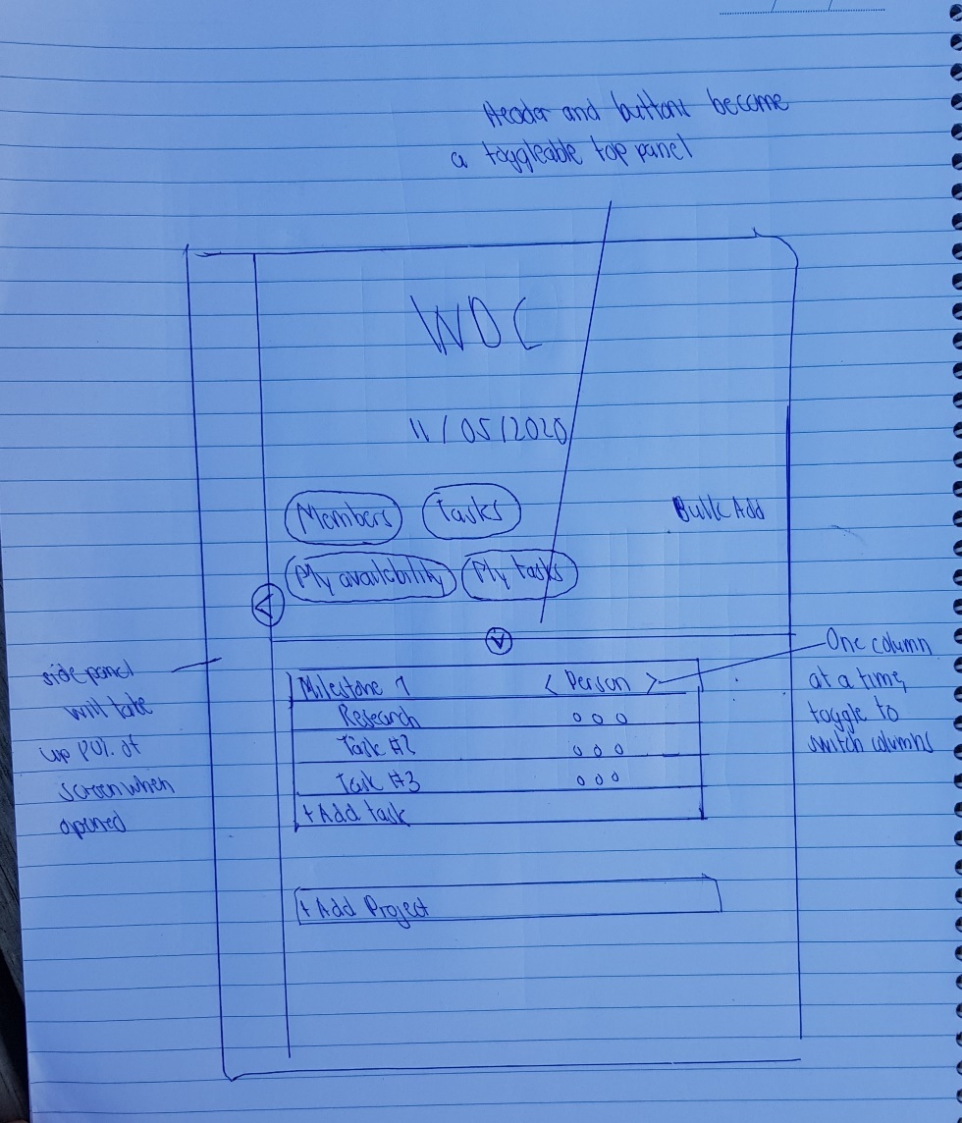

*Figure 7: Mobile view of the homepage*

**Profile page (index.html)**

* Profile picture on top half div
* Top half div is coloured
* Personal info tab
  + Text input to change
* Password tab
  + Text input to change password

*Figure 8: Profile page*

**Landing page**

* Navigation bar containing logo, about us, contact, log in and sign up button
* Stays persistent while scrolling
* A slogan page centre
* Sign up button below
* Further scrolling down shows reviews and website features

*Figure 9: Landing page*

**Login/signup page**

Sign up

* A white page with a small window that contains fields to enter email and password
* Has option to sign up via social media
* Once signed up, switches to another small window asking for name
* Takes user to homepage with an empty board list

Log in

* A white page with a small window that contains fields to enter email and password
* Has option to log in via social media.

*Figure 10: Login page*

*Figure 11: Sign up page*

**Features**

**Sign up / login**

* Registration method for new users and log in method for current users.

**Link Social Media**

* In the login and sign up window, there is social media or google login to link the account for easier login.

**Email notification**

* When managers add a task, an email will be sent to the employee(s) they set it to. The email will contain the attributes of that task

**Calendar**

* Boards will utilize google calendars to provide a foundation for scheduling the tasks and day offs.

**Side panel**

* Toggle to hide or unhide. Persistent across many boards to provide an anchor for the user.

**About us / contact info**

* Located in the bottom of the side panel and footer of the landing page to provide information about us.

**How to use as a manager**

|  |  |
| --- | --- |
| 1. Sign up page | Create an account. The website will automatically take you to the homepage upon signing up. |
| 1. Main page -> Side panel | On the side panel, click “Add board”. Name this board to finalise it. |
| 1. Main page -> Board | The website will open the board as your homepage |
| 1. Main page -> Board -> Members | Click on “members”. This will open a small window within the page. Enter the email of the members you’d like to add. |
| 1. Main page -> Board -> Members | The members will receive a request for them to join your board, upon approval, they will be a part of the board. |
| 1. Main page -> Board -> Members | Close the members window. |
| 1. Main page -> Board -> Tasks | Click on “tasks” to add tags for the most common tasks you will set |
| 1. Main page -> Board | Click on “Add project” to create a task group. Name this project to finalise it. |
| 1. Main page -> Board | Click on “Add task” to create the task and assign it to a member |

**How to use as an employee**

|  |  |
| --- | --- |
| 1. Sign up page | Create an account. |
| 1. Main page | The website will automatically take you to the homepage upon signing up. |
| 1. Main page -> Side panel | On the side panel, click requests. |
| 1. Main page -> Side panel -> Requests | Accept the invitation of your manager to their board |
| 1. Main page -> Board | The website will add their board to your board list. It will open this board as your homepage |
| 1. Main page -> Board -> My availability | Click “My availability” and set your availability. |
| 1. Main page -> Board -> My tasks | Click “My tasks” and set your task preferences. |
| 1. Main page -> Board | Once assigned a task, you can click on status to change it to complete. |

**How to request a day off**

Employee

|  |  |
| --- | --- |
| 1. Main page -> Side panel | Select a board |
| 1. Main page -> Board | Click on “My availability” |
| 1. Main page -> Board -> My availability | Click on day(s) on the calendar |
| 1. Main page -> Board -> My availability | Click submit |
| 1. Main page -> Board -> My availability | Wait on manager’s response |
| 1. Main page -> Board -> My availability | The status of the request will show up under the calendar: Pending, approved or denied. |

Manager

|  |  |
| --- | --- |
| 1. Main page -> Side Panel | Select a board |
| 1. Main page -> Board | Click on “Members” |
| 1. Main page -> Board -> Members | Click on the picture of the member with the red dot |
| 1. Main page -> Board -> Members | Click Accept or Deny. The red dot will disappear and the response will be sent to the employee. |